**The Kitchen Story**

1. **The Kitchen Story:**

**This document contains sections for:**

* Project Description
* Core concepts used in project
* Flow of the Application.
* Project Users Stories : ( Agile and Scrum )
* Git Repositories
* How to run project
* Demonstrating the product capabilities, appearance, and user interactions.
* Unique Selling Points of the Application
* Conclusions

The code for this project is hosted at :

<https://github.com/KUSALA-sura/Kitchen-Story-Phase4-project>

The project is developed by Sura Kusala

* 1. **Project Description:**

DESCRIPTION

Project objective:

Kitchen Story is an e-commerce portal that lets people shop  basic food items on their website. The website needs to have the following features:

* A search form in the home page to allow entry of the food items to be purchased by the customer.
* Based on item details entered, it will show available food items with  price.
* Once a person selects an item to purchase, they will be redirected to the list of available items. In the next page, they are shown the complete breakout of the order and details of the payment to be made in the payment gateway. When payment is done, they are shown a confirmation page with details of the order.

For the above features to work, there will be an admin backend with the following features:

* Admin login page where admin can change password after login if he wants to
* A master list of food items available for purchase
* A functionality to add or remove food items

* 1. **Core concepts used in the project:**

-> VS Code

-> TypeScript

-> HTML

-> CSS

-> BootStrap

TECHNOLOGIES AND TOOLS USED:

Spring MVC: to build web applications as it follows the Model-View-Controller design pattern.

• Java Script: to handle the presentation view more beautiful.

• Visual Studio / Notepad: to Write the code .

• CSS: to format the contents.

• HTML: To make a Structure to websites

**Architecture diagram / flow chart**

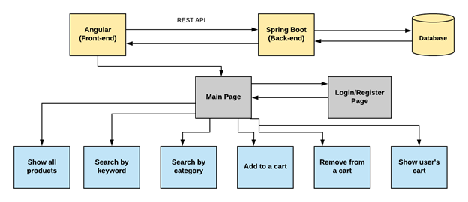

* 1. **Project Users Stories : ( Agile and Scrum )**

The project is planned to be completed in 3 sprints. Tasks assumed to be completed in the sprint are:

* Creating the flow of the application
* Initializing git repository to track changes as development progresses.
* Writing the Java program to fulfill the requirements of the project.
* Testing the Java program with different kinds of User input
* Pushing code to GitHub.

1) As an admin I can Set up a product list of all the shoes.

2) As an admin I can Delete any shoe product.

3) As an admin I can Manage users.

4) As an admin I can change new password.

5)As a User, I can add product to the list.

The goal of the company is to deliver a high-end quality product as early as possible.

Sprint 1

1. User Can Register the Web Page..

Sprint 2ss

1. Create login and register pages.Show all products to the home page.
2. Add products to the cart.Show user’s cart. Create user’s update page.
3. Enable the admin to add a new product. Enable the ability to search for a specific product.

Sprint 3

1. Make the admin able to update and remove a product. Make the admin manage the users.
2. Make the admin manage the orders. Add CSS file and use Bootstrap to format the pages. Debug and test the project.
3. Push the code to the GitHub.

The goal of the company is to deliver a high-end quality product as early as possible.

**3. Project git Repositories**

1. link <https://github.com/KUSALA-sura/Kitchen-Story-Phase4-project>

2. clone git : <https://github.com/KUSALA-sura/Kitchen-Story-Phase4-project>.git

3. Screen shot :

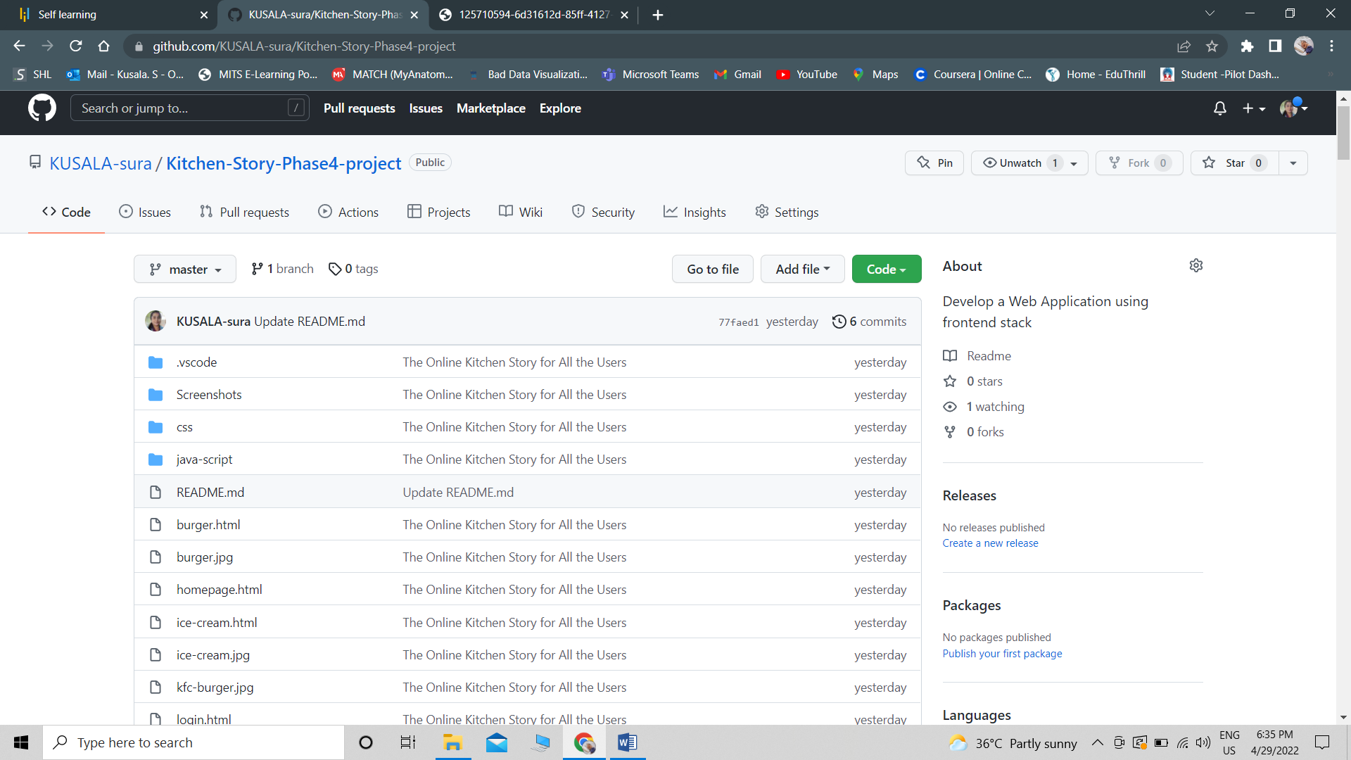

**4. How to run poject:**

4.1. clone project

clone git : git clone <https://github.com/KUSALA-sura/Kitchen-Story-Phase4-project>

4.2. open phase4-kitchenstory-> right click -> run on server

## **Demonstrating the product capabilities, appearance, and user interactions**

To demonstrate the product capabilities, below are the sub-sections configured to highlight appearance and user interactions for the project:

## **Step 1:** Creating a new project in Eclipse

* Open VS Code
* Go to Open Folder ->Open Terminal ->Next.
* Type in any project name and click on “Finish.”

All above mentioned file are attached via zip file all these are

**Outputs:**

Registration Page

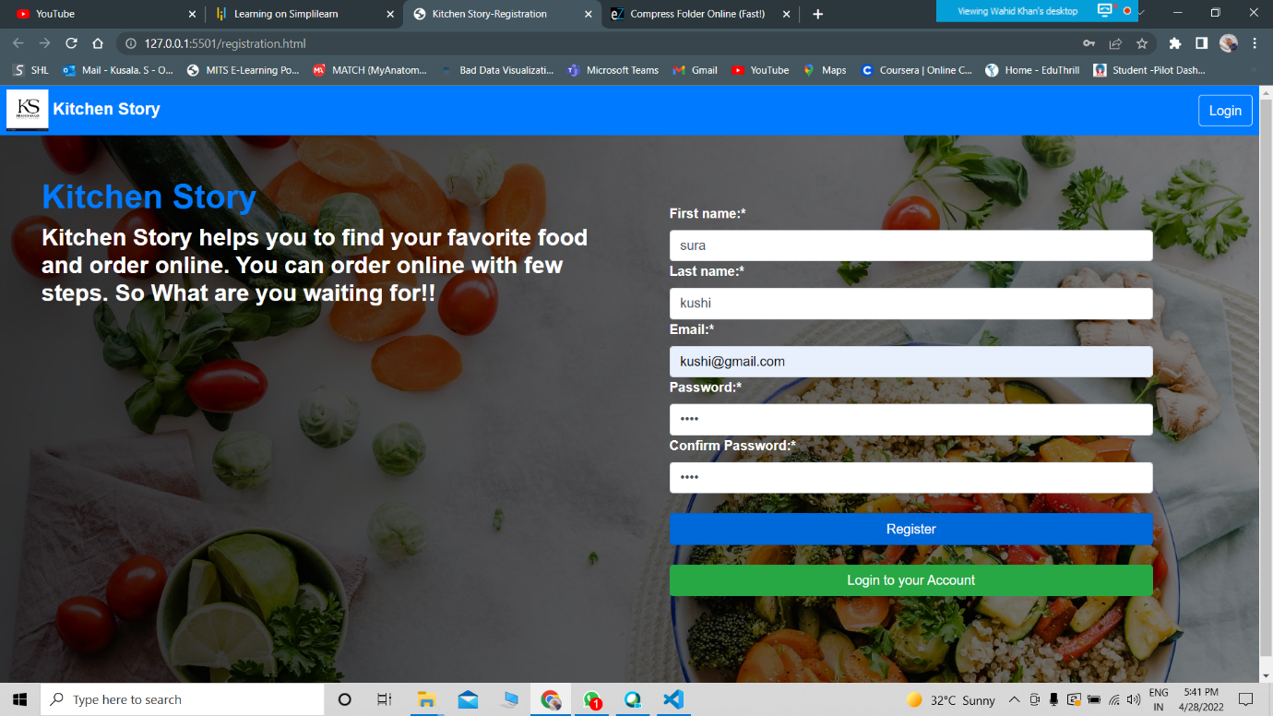

Login

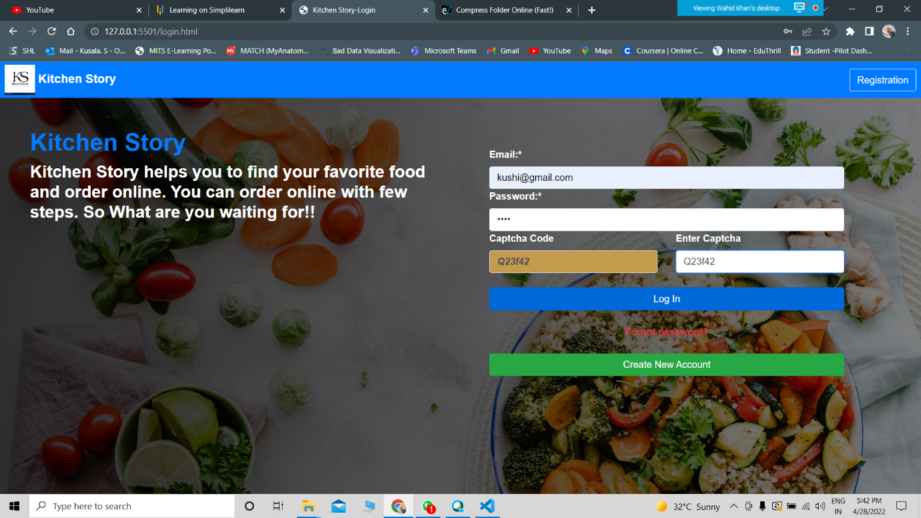

## valid credentials

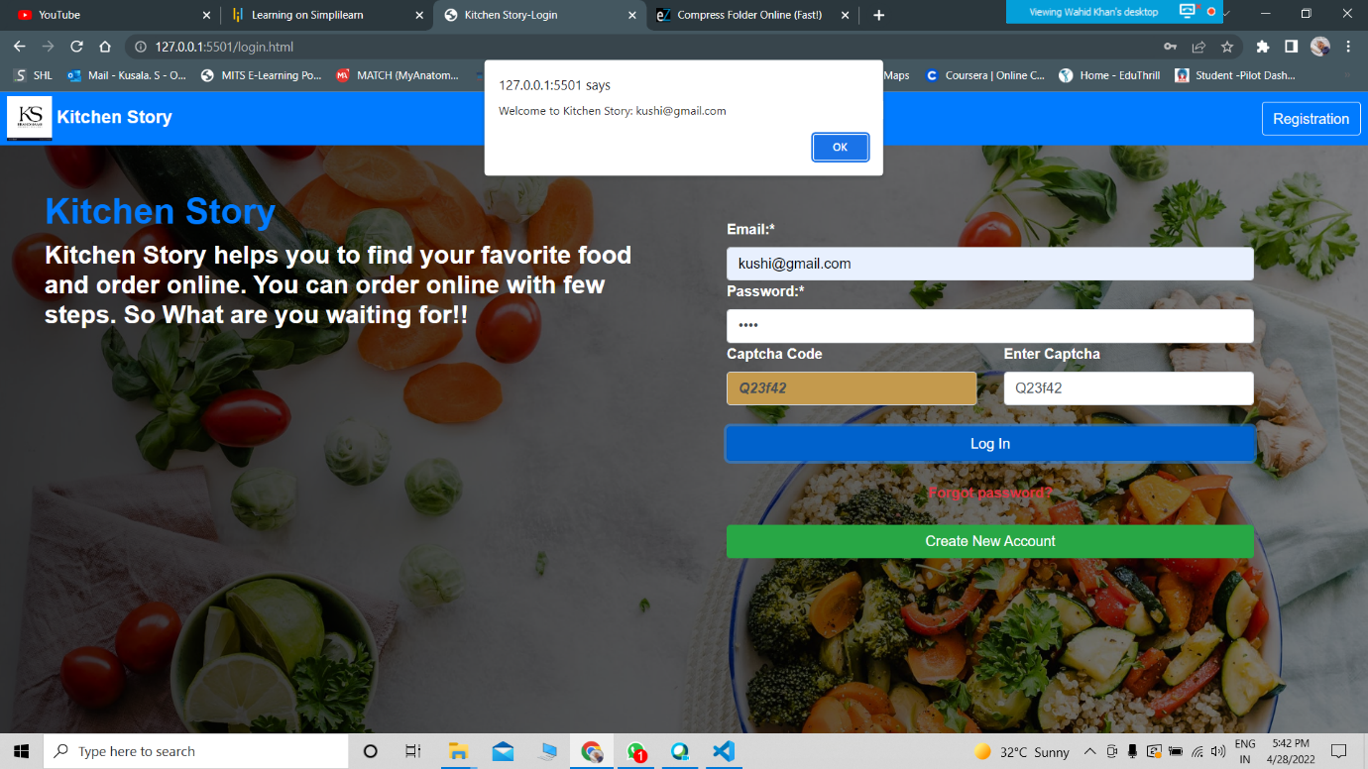

Home Page For Order

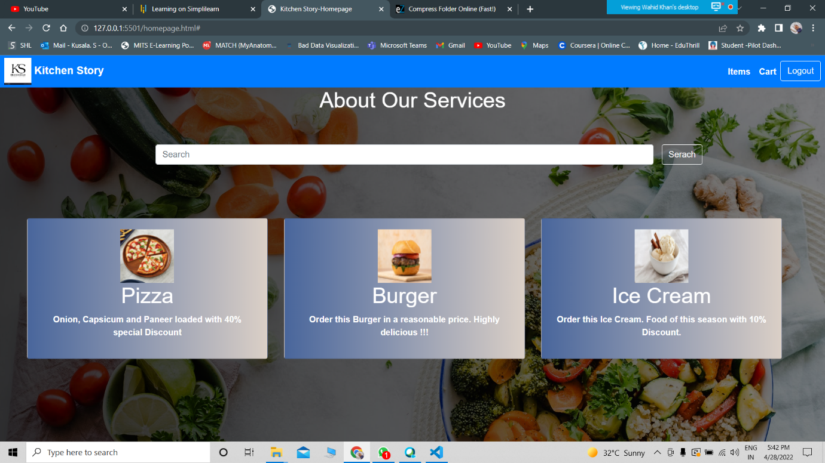

Order Item

-------------

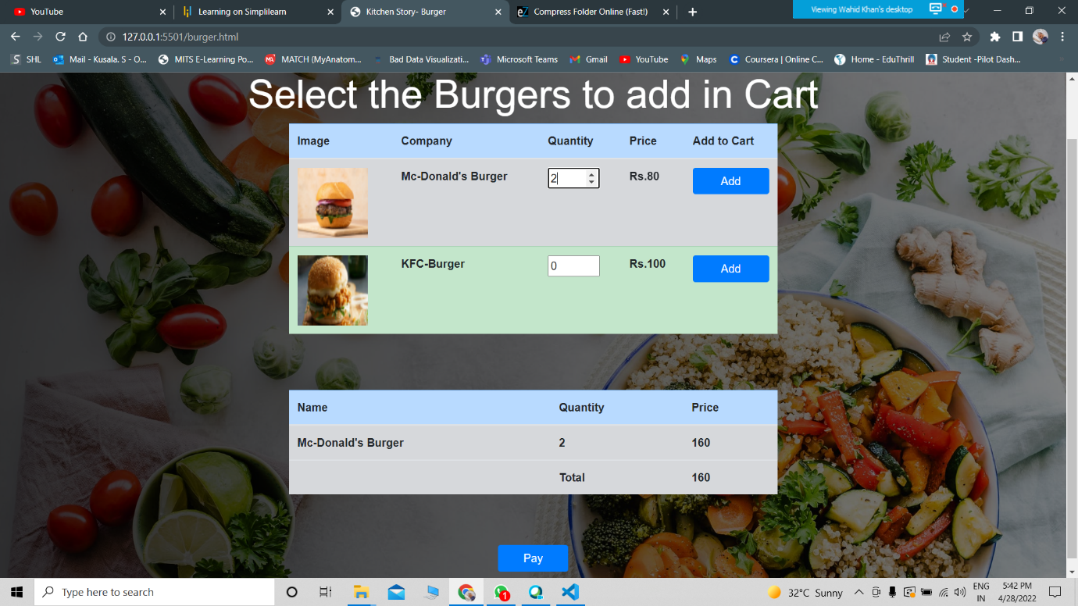

## Oder Conformation

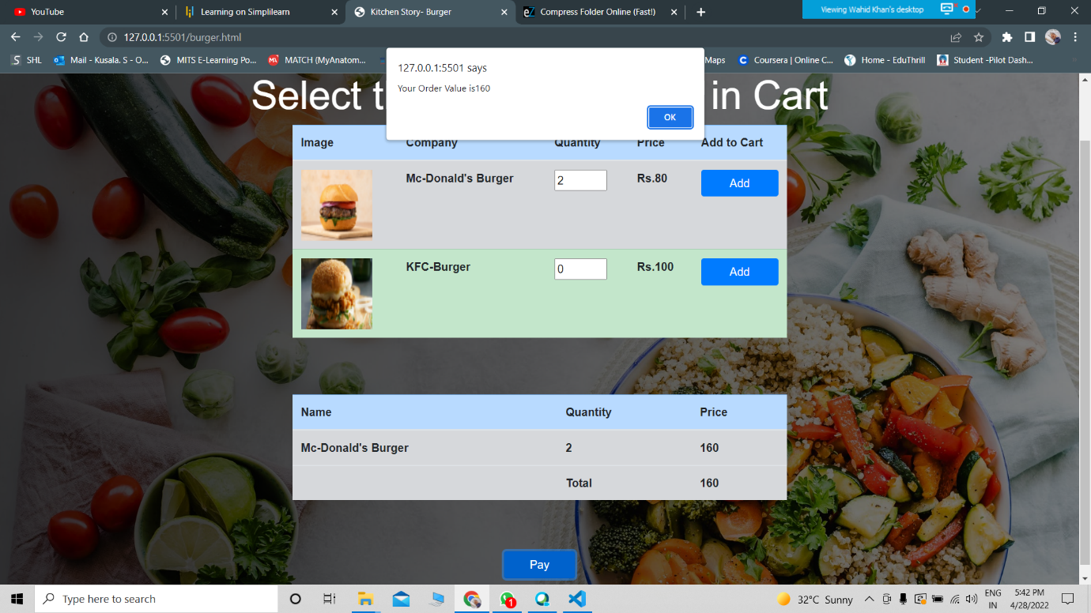

Ordered detailes

--------------------

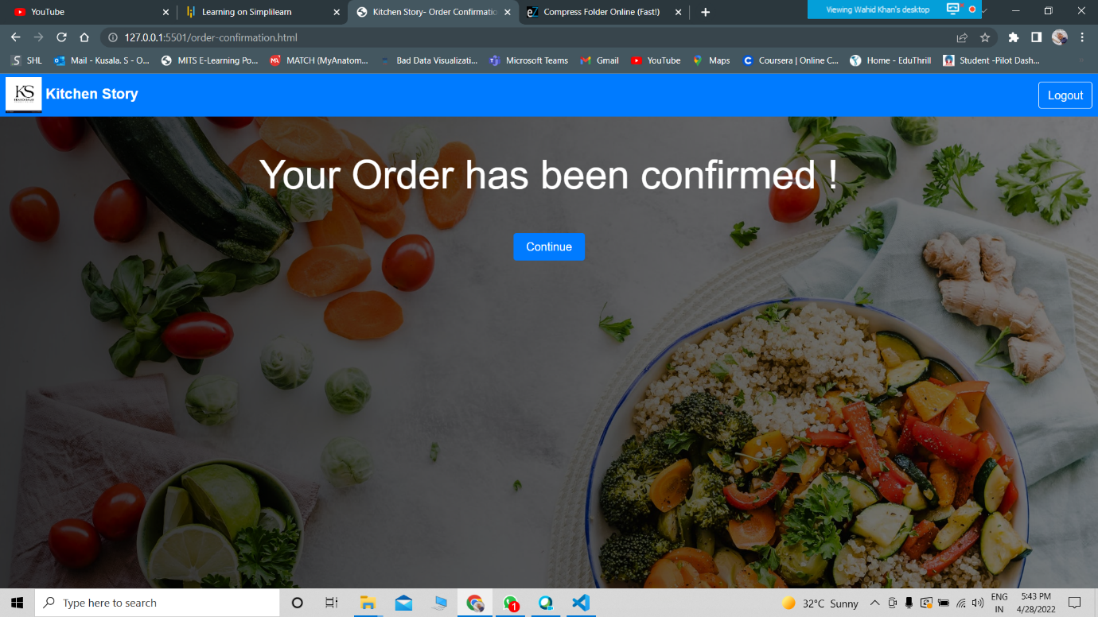

Search Item

-------------------------

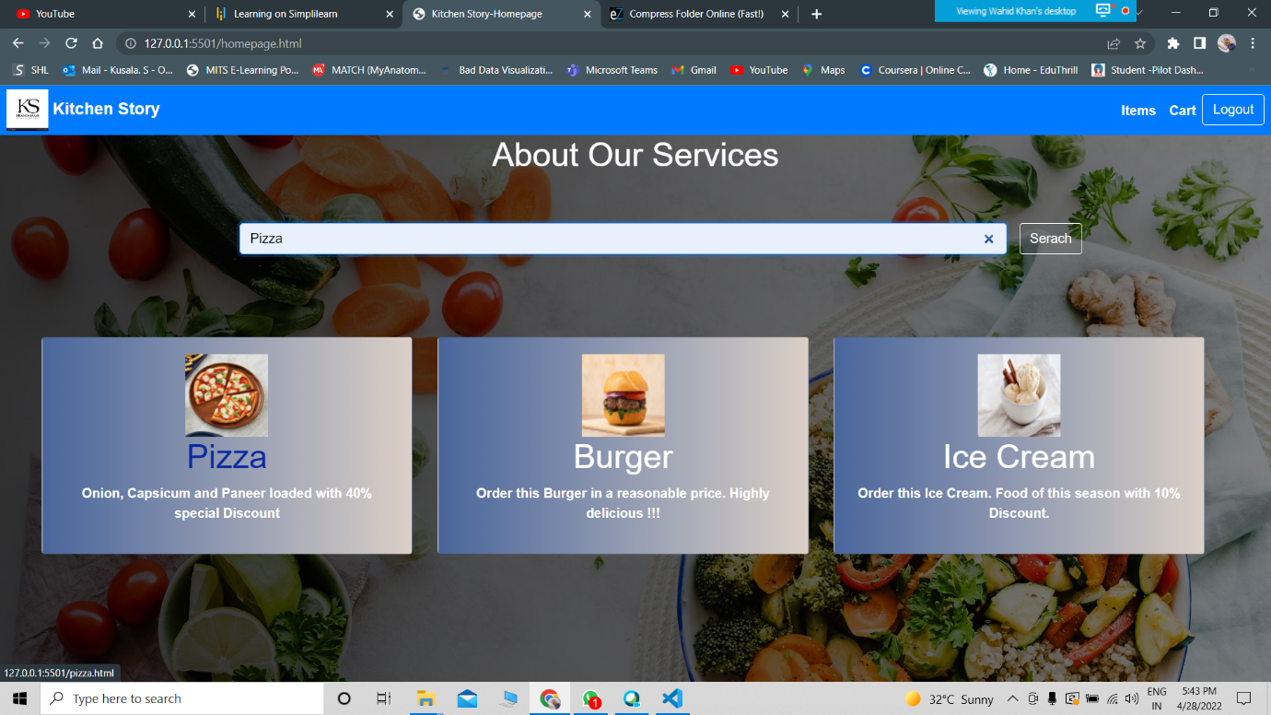

## LogOut Page

---------------------------------

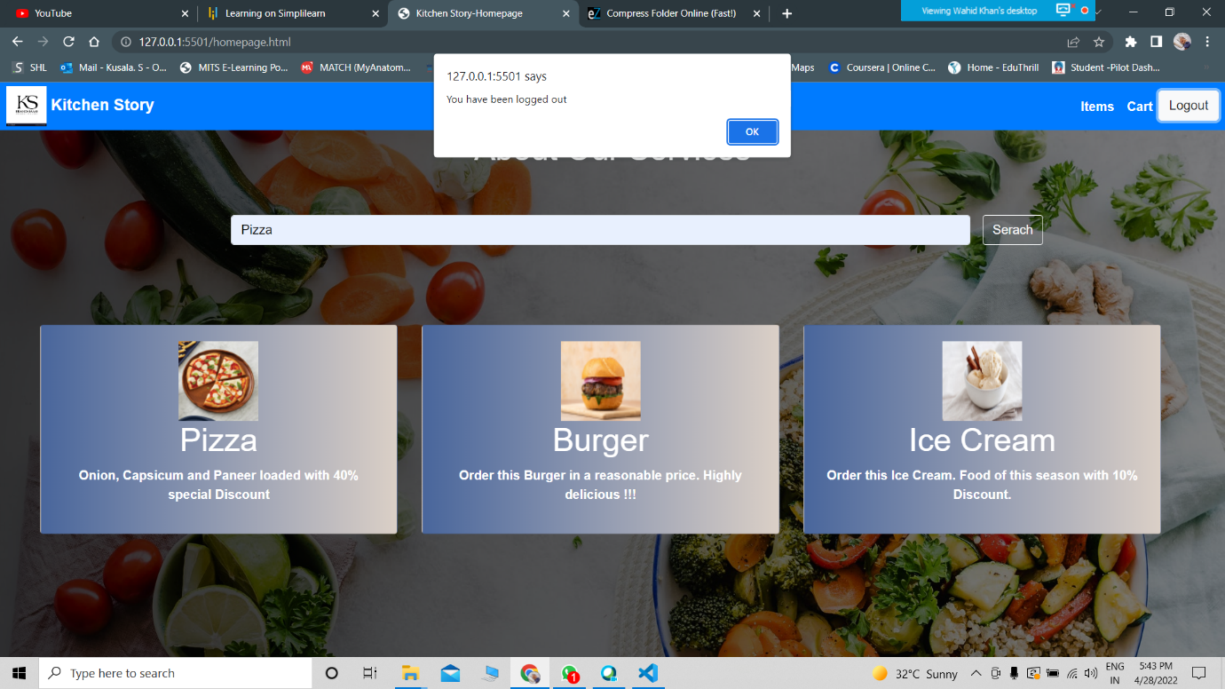

## ss**Step 4:** Pushing the code to GitHub repository

* Open your command prompt and navigate to the folder where you have created your files.

*cd <folder path>*

* Initialize repository using the following command:

*git init*

* Add all the files to your git repository using the following command:

*git add .*

* Commit the changes using the following command:

*git commit . -m <commit message>*

* Push the files to the folder you initially created using the following command:

*git push -u origin master*

## **Unique Selling Points of the Application**

1. Scheduled kitchen products for users can be maintained easily.
2. The data of the users and products can be edited easily.
3. High security for the data as the admin only can access the data.
4. Searching for any data about users is made easy

## **Conclusions**

In the program an application has been developed with a duration of three spirits. This application makes handling the data of the Kitchen products. All the data about the Kitchen products, user’s purchase details and their schedule are maintained. The admin can login through a User ID and password and manipulated the data.